Written as of July 19, 2021 – CURRENT VERSION OF THE “business_cycles_dates.json” is as of July 10,2021, the “business_cycles_dates.json” is actively used in the graphic on the homepage and is manually overwritten everytime there is a new update to the business cycle dates

(3) items are in this folder:

1. business_cycle_dates.json (final product)
   * This is the json file for the grey shaded boxes that represent the recession dates on the unemployment rate animation on the NBER homepage utilized by developer Alex Denisov
   * 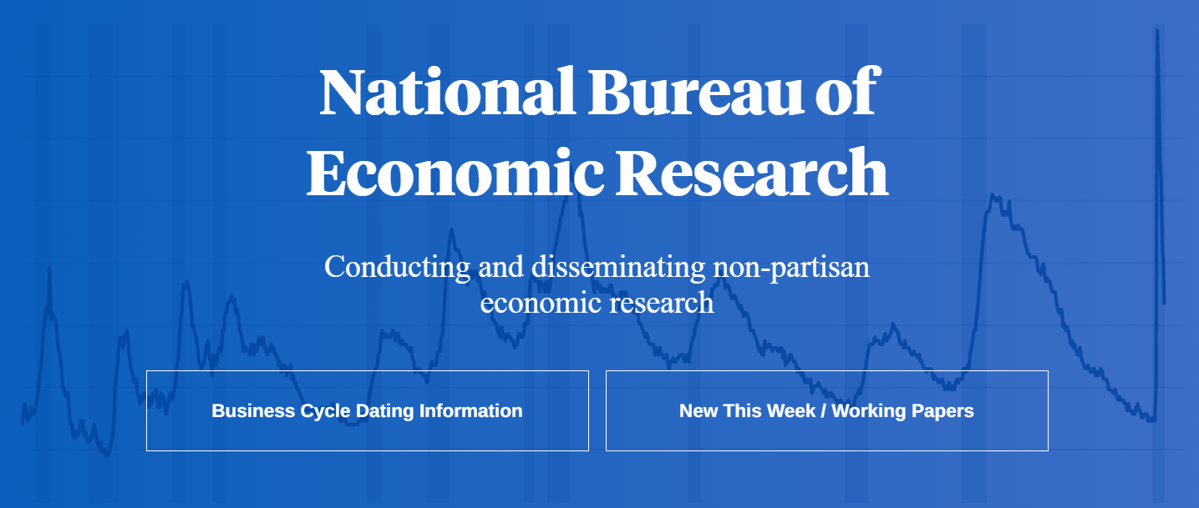
2. 20210719 _cycle dates pasted.csv
   * + This is a list of the peak and trough dates as determined by NBER on this page as of the date above [US Business Cycle Expansions and Contractions | NBER](https://www.nber.org/research/data/us-business-cycle-expansions-and-contractions)
3. 20210719_recession dates.R - Item (2) was read into R Studio to output item (1)

Steps to update after a new business cycle date has been added to:

1. Receive updated spreadsheet with new business cycle date usually from the page [US Business Cycle Expansions and Contractions | NBER](https://www.nber.org/research/data/us-business-cycle-expansions-and-contractions)
2. “Save as” - cycle dates pasted.csv and update the new rows with the new dates.
   1. All dates must be formatted as dates in CSV according to “YYYY-MM-DD”
3. This will be read into recession dates.R and rerun
   1. Copy the R output into a text file and rename as .json (for some reason when you export write_json, it messes up the format)
   2. The format should look like the current
4. We decided to not use the /homes/data/cycles directory and keep using the /homes/data/data/cycles/business_cycles_dates.json and just overwrite that file going forward